Indicate if you are presenting a scientific abstract or a case study.
This is how the title of your extended abstract should look
Gunter Fish-Fish¹, Helmut Sludge², and Susan Water^{3*}
¹Department of Civil Engineering, Technical University of Acity, Denmark
²Department of Environmental Engineering, University of Cdorf, Canada
³Department of Biotechnology, Ztown University of Technology, Germany
*Corresponding author: s.water@bio.uztown.de
Keywords: Keyword1; keyword2; keyword3 (maximum number of keywords is 3)
Abstract: Give no more than 100 words briefly specifying the aims of the work, the main results obtained, and the conclusions drawn.
Introduction - please use 12pt Times New Roman bold for all headings
This is our preferred style for all first paragraphs after headings: the text (set in 12pt Times New Roman) is justified, with no indent. Insert one line space between paragraphs.
All subsequent paragraphs are indented and justified. The maximum acceptable length for a paper is two A4 pages (and additionally max. 2 pages of figures and tables), incorporating all text and references, always respecting a limit of 1000 words.
Your Introduction section should clearly set out the background and the objectives of your work. Do not number or letter section headings.
Material and Methods
Please include a brief description of the methods/techniques used (the principles of these methods should not be described if readers can be directed to easily accessible references or standard texts).
Results and Discussion
This section should summarise clearly the experimental results obtained or the major outcomes of the performed study. Any trends or points of interest should be highlighted, and their significance explained.
All major results presented in the paper should be supported and/or proved by graphical presentations or tabular results.
Conclusions
This should give a brief explanation of the significance and implications of the work reported, and highlight any “take-home message” you wish to communicate.
References
These should be to accessible sources. Please ensure that all work cited in the text is included in the reference list and that the dates and authors in the text match those in the reference list.

For citation in the main text use surname of author and year of publication: Jones (2002) or (Jones, 2002). Insert initials only if there are two different authors with the same surname and same year of publication. The abbreviation "et al." should be used in the text when there are more than two co-authors of a cited paper.
References should be listed alphabetically at the end of the paper. Although "et al." is preferable in the text, in the list of references all authors should be given. References must always be given in sufficient detail for the reader to locate the work cited (see examples below).

Bell J. (2002). Treatment of Dye Wastewaters in the Anaerobic Baffled Reactor and Characterisation of the Associated Microbial Populations. PhD thesis, Pollution Research Group, University of Natal, Durban, South Africa.
Henze M., Harremoës P., LaCour Jansen J. and Arvin E. (1995). Wastewater Treatment: Biological and Chemical Processes. Springer, Heidelberg.
McInerney M. J. (1999). Anaerobic metabolism and its regulation. In: Biotechnology, J. Winter (ed.), 2nd edn, Wiley-VCH Verlag, Weinheim, Germany, pp. 455-478
Sobsey M. D. and Pfaender F. K. (2002). Evaluation of the H2S method for Detection of Fecal Contamination of Drinking Water, Report WHO/SDE/WSH/02.08, Water Sanitation and Health Programme, WHO, Geneva, Switzerland.
Standard Methods for the Examination of Water and Wastewater (1998). 20th edn, American Public Health Association/American Water Works Association/Water Environment Federation, Washington DC, USA.
Zeng R. J., Lemaire R., Yuan Z. and Keller J. (2004). A novel wastewater treatment process: simultaneous nitrification, denitrification and phosphorus removal. Water Science and Technology,50(10), 163-170.

Figures and Tables
If you wish to present your results in a tabular form or by using graphical presentations, please use the following formats for tables and figures.
Please ensure that all figures are clearly labelled:

Table 1 This is a style for table captions. “Table 1, 2 etc” should be in bold. Table captions should appear above tables.
 | Text area | US (Imperial) paper
 | (mm) | (mm) | (in)
Depth | x | 279.4 | 11.0
Top/bottom margin | - | x | x
Width | x | 215.9 | 8.5
Left/right margin | - | x | x

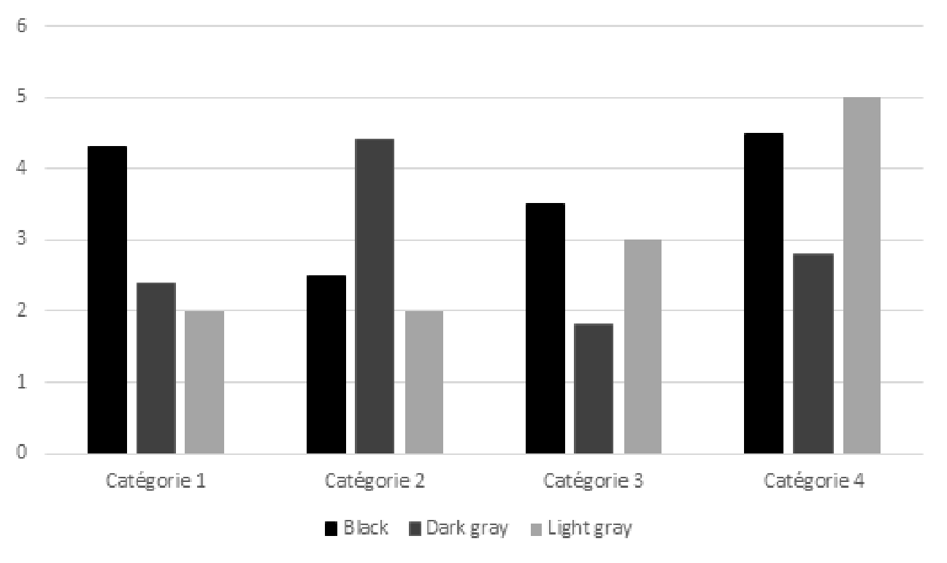
Figure 1 This is a style for Figure legends. “Figure 1, 2 etc” should be in bold. Figure legends should appear below figures.

